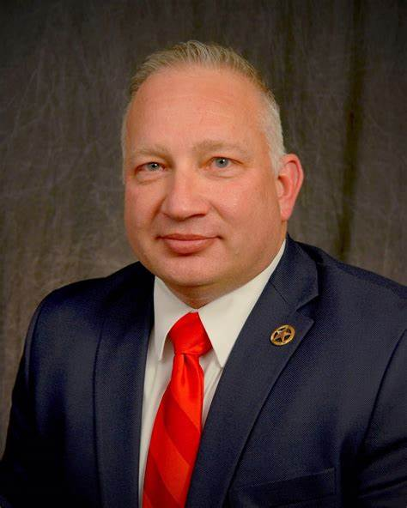
Director Donnie Anderson - Bio

Donnie Anderson is the Director of the Oklahoma State Bureau of Narcotics and Dangerous Drugs Control (OBNDDC).
Director Anderson, a native Oklahoman, began his law enforcement career over 30 years ago at the Garvin County Sheriff’s Office. During his time at the Sheriff’s Office, Anderson served as both Undersheriff and Sheriff.
He then served as Task Force Commander for the District 21 Drug and Violent Crime Task Force, which includes Garvin, McClain, and Cleveland counties.
Before his appointment to OBNDDC, Anderson served as the Oklahoma Inspector General for the Oklahoma Department of Corrections.
He graduated summa cum laude from the Central Christian College of Kansas with a bachelor’s degree in Criminal Justice.

